Anja Schwobe Final Project - Site Map CNMT 210 11/18/2022

Normal-Oriented View

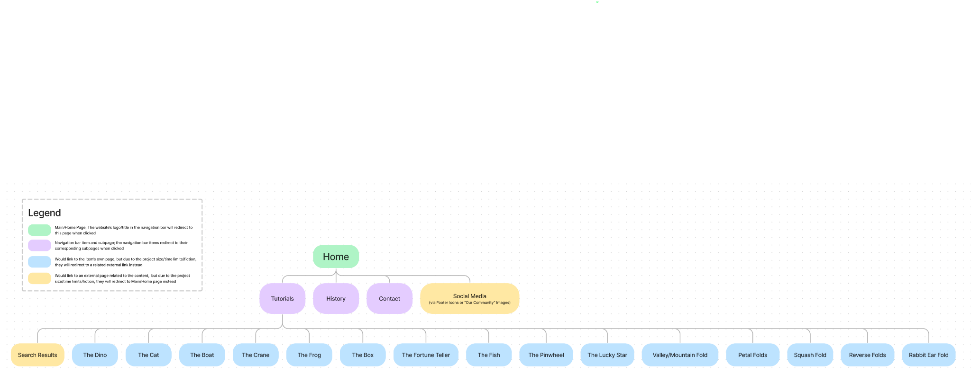

Split-Oriented View

